**Instructions for the Unstructured Analytics Utility, written by Pierre Richer**

From the command prompt, start the Tomcat instance to run the utility:

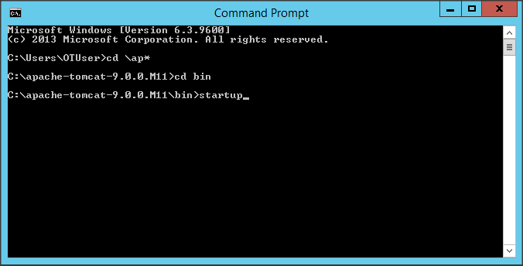

From the Start menu, start MySQL:



In MySQL, double-click on Local instance:

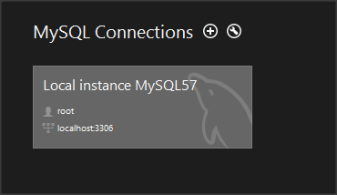

In MySQL Editor, go to File --> New Query Tab. Copy and run the following script to delete existing data:

DELETE from unstructured.ca_categories;

DELETE from unstructured.ca_concept_subterms;

DELETE from unstructured.ca_concepts;

DELETE from unstructured.ca_geo;

DELETE from unstructured.ca_sentiment_documents;

DELETE from unstructured.ca_sentiment_sentences;

DELETE from unstructured.ca_summaries;

DELETE from unstructured.ca_term_subterms;

DELETE from unstructured.ca_terms;

DELETE from unstructured.categories;

DELETE from unstructured.document_meta;

DELETE from unstructured.document_source_meta;

DELETE from unstructured.document_sources;

DELETE from unstructured.documents;

DELETE from unstructured.terms;

From the utility (<http://localhost:8080/web-load>), select “Test Project”, password is “test”, click on “Choose File” and select UnstructuredAnalytics.zip:

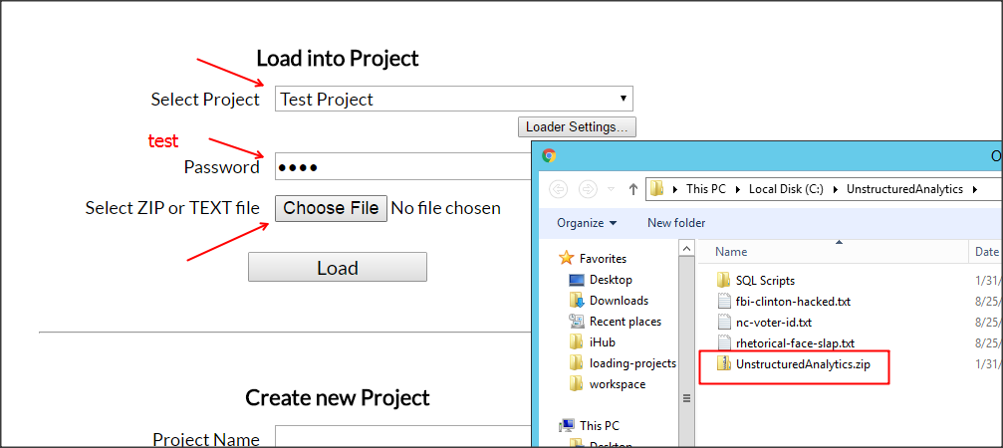

Click on Load. You should get 3 files loaded:

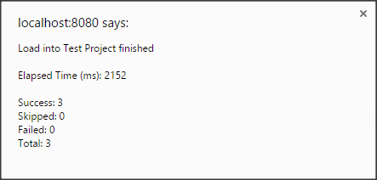

In MySQL, you can now see the data loaded into the different tables. (Not all tables are populated)

Now, as one-time offer because you are a repeat customer, I am including a BIRT project that I have built that queries the MySQL database and creates a poor man’s version of Election Tracker. You can use it to dazzle your audience!

Enjoy!!!

P.